**ASSESSMENT- 2**

**Name: Sachin Bharti**

**Mail:** [**sachin.bharti2020@vitstudent.ac.in**](mailto:sachin.bharti2020@vitstudent.ac.in)

**Reg. No: 20BCI0117**

**Assignment: Bash Shell Basics**

**Task 1: File and Directory Manipulation**

1. Create a directory called "my_directory".

***mkdir my_directory***

1. Navigate into the "my_directory".

***cd my_directory***

1. Create an empty file called "my_file.txt".

***touch my_file.txt***

1. List all the files and directories in the current directory.

***ls***

1. Rename "my_file.txt" to "new_file.txt".

***mv my_file.txt new_file.txt***

1. Display the content of "new_file.txt" using a pager tool of your choice.

***less new_file.txt***

1. Append the text "Hello, World!" to "new_file.txt".

***echo "Hello, World!" >> new_file.txt***

1. Create a new directory called "backup" within "my_directory".

***mkdir backup***

1. Move "new_file.txt" to the "backup" directory.

***mv new_file.txt backup/***

1. Verify that "new_file.txt" is now located in the "backup" directory.

***ls backup***

1. Delete the "backup" directory and all its contents.

***rm -r backup***

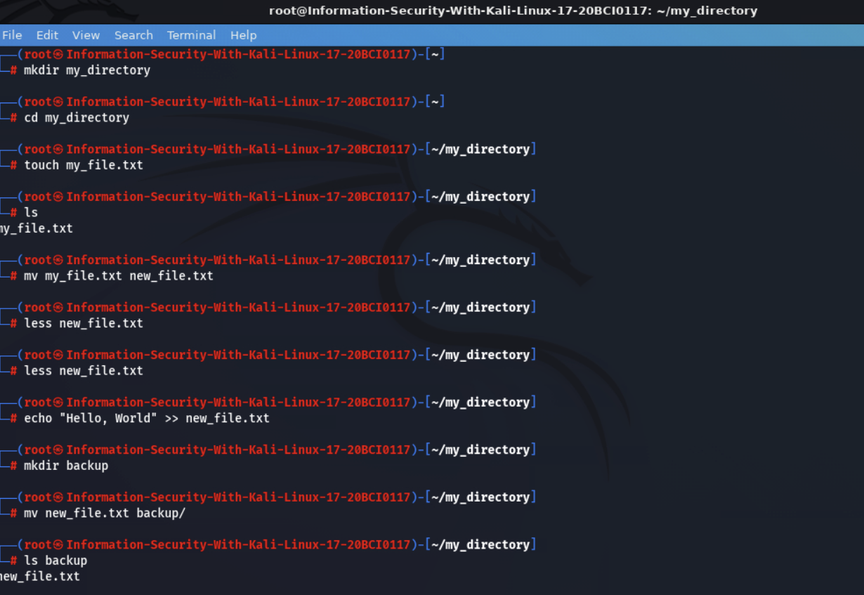

Output for *less new_file.txt:*

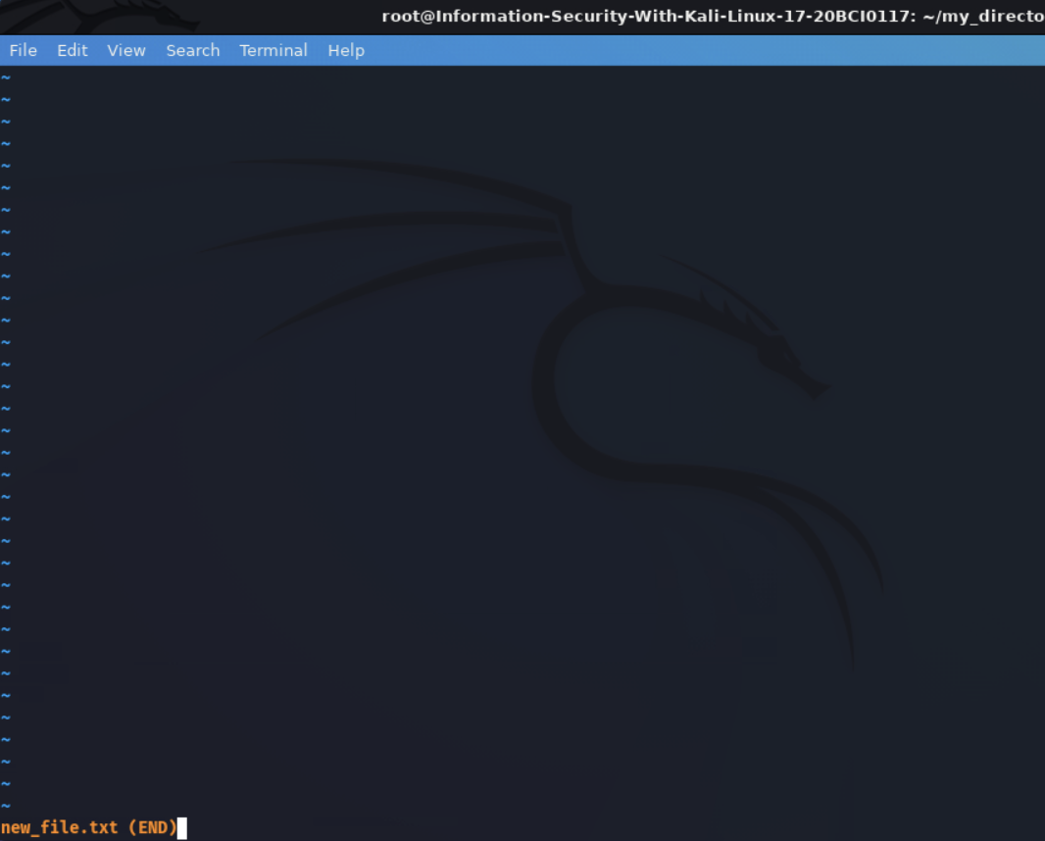

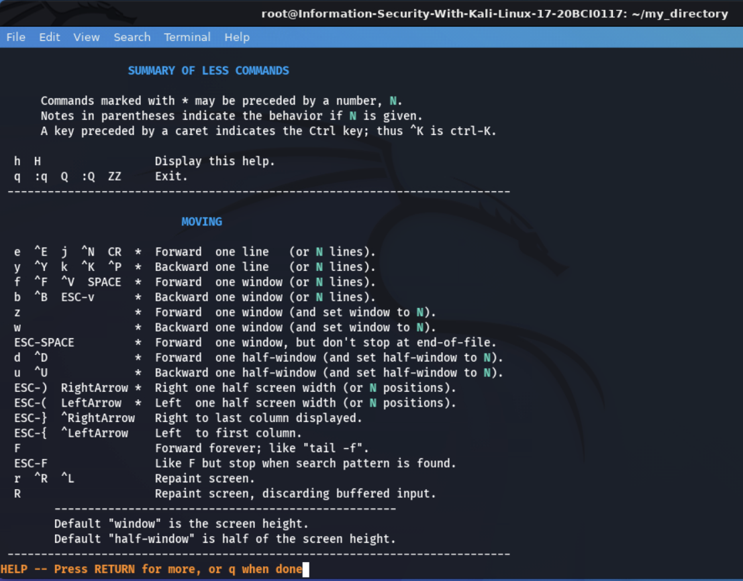

Deleting Backup:



Showing the proof of deleted backup:



**Task 2: Permissions and Scripting**

* Create a new file called "my_script.sh".

***touch my_script.sh***

* Edit "my_script.sh" using a text editor of your choice and add the following lines:

**bash**

**#!/bin/bash**

**echo "Welcome to my script!"**

**echo "Today's date is $(date)."**

**Save and exit the file.**

***nano my_script.sh***

* Make "my_script.sh" executable.

***chmod +x my_script.sh***

* Run "my_script.sh" and verify that the output matches the expected result.

***./my_script.sh***

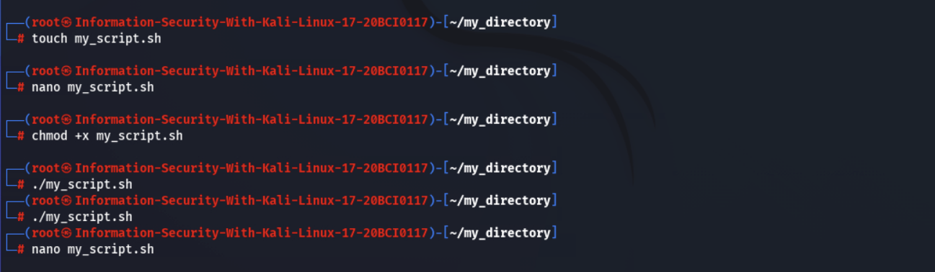

**Writing inside “my_script.sh” using *nano my_script.sh***

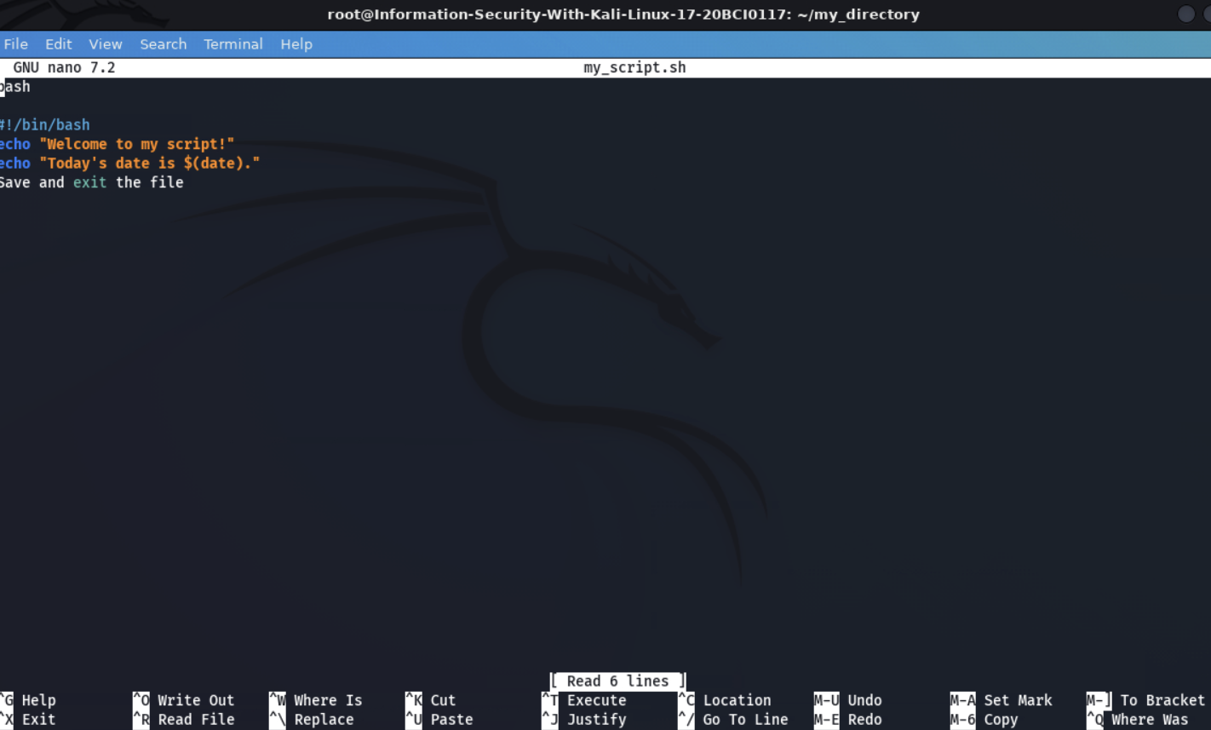

**I tried all the commands to run the “my_script.sh” but didn’t get any output.**

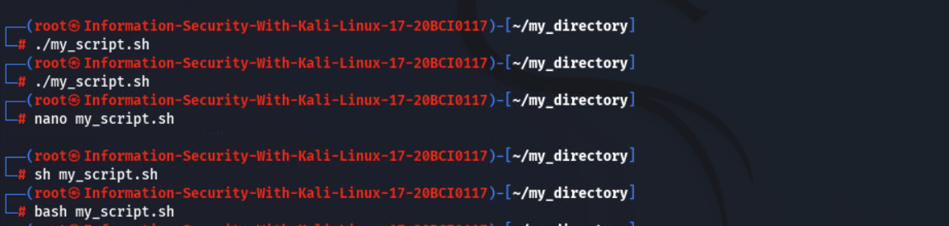

**Task 3: Command Execution and Pipelines**

* List all the processes running on your system using the "ps" command.

***ps aux***

* Use the "grep" command to filter the processes list and display only the processes with "bash" in their name.

***ps aux | grep bash***

* Use the "wc" command to count the number of lines in the filtered output.

***ps aux | grep bash | wc***

